Old Fashion Pancakes
Ingredients  - 1 1/2 cups all-purpose flour  - 3 1/2 teaspoons baking powder  - 1 teaspoon salt  - 1 tablespoon white sugar  - 1 1/4 cups milk  - 1 egg  - 3 tablespoons butter, melted  Yield: 6 to 8 | 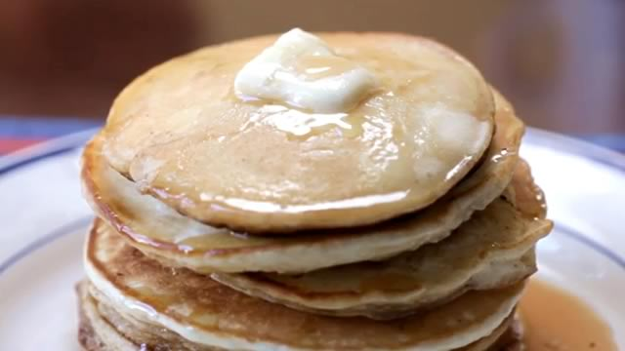

Directions
- In a large bowl, sift together the flour, baking powder, salt and sugar. Make a well in the center and pour in the milk, egg and melted butter; mix until smooth (don’t over mix).
- Heat a lightly oiled griddle or frying pan over medium high heat. Pour or scoop the batter onto the griddle, using approximately 1/4 cup for each pancake. Brown on both sides and serve hot.

